Family # 1:
First name: Narod
Last name : Khavdrash
Age: 57
Lives in: Sogoog
Family size : 7

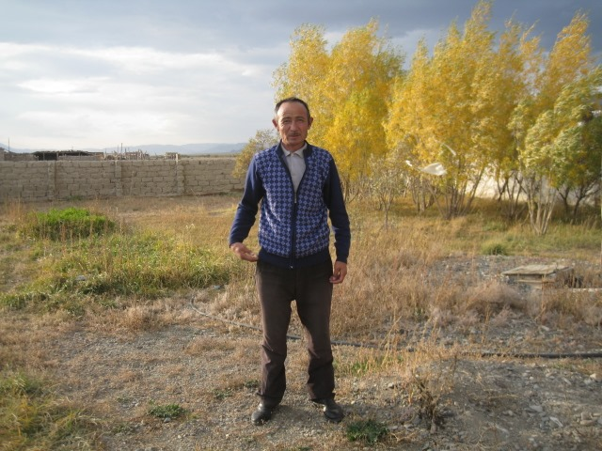

Why do you want to have green house?
- To grow eco vegetables with high nutrition.
- To improve family income.

How many kg harvest would you like to get per year?
I would like to get harvest in high season three times a week (total of 150 kg):
- 30% of harvest I would like to use for my family
- 60% will be sold
- 10 % will be stored for next year

Family # 2
First name: Seserhan
Last name : Aseman
Age : 60
Lives in: Sogoog
Family size : 9

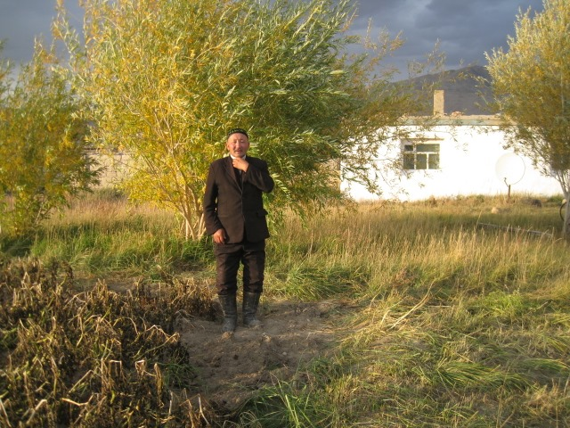 | 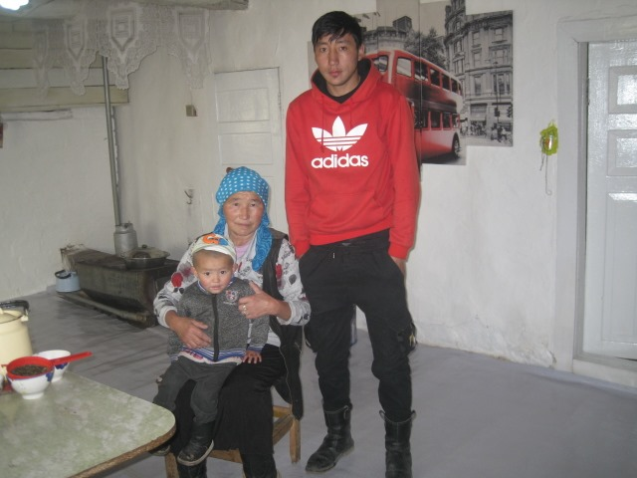

Why would you like to have green house ?
- To grow eco vegetable and berries
- To eat healthy and eco harvest
- To provide locals with healthy harvest
- To change diet of my family, it would change my family life.
How many kg harvest would you like to get per year?
It depends on the soil and the seeds:
- 65% for my family ( hopefully 60 kg)
- I would like to sell 30%
- 5 % will be stored for next year seed
Family # 3:
First name: Nurbolat
Last name : Sumynhan
Age : 35
Lives in: Sogoog
Family size: 6

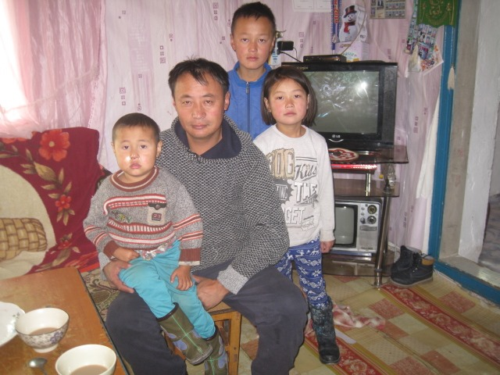

Why do you want to have green house?
I want to grow vegetables with high nutrition for several reasons:
- To change my family diet
- To improve my children’s health.
- To improve my family income.
- To be healthy and have happy family.
How many harvest would you like to get per year?
It depends quality of seeds. We will work hard to get enough harvest because my family needs it very much:
- I would like to use 50% of total harvest to feed my family;
- I will keep 10% of harvest for next year’s seed;
- Rest 40 % will be sold under the marker price.

