I am Lena Khazidolda,

I was born in Ulaankhus soum, Bayan-Ulgii province. I grew up at there. I have a lot of experience and memorable child hood memories of herdsmen families because when I was a child I used to spend my summer vacation with my grandparents who were herders.

All herders move four times a year because they follow animal pastures. They used to move by camel. Distance from winter camp to summer camp is around 200- 250 km. The camps are usually isolated and surrounded by bumpy roads. This area is called Dayan bagh of Ulaankhus soum.

Ulaankhus is central administrated area which has 9 different baghs, all of them are inhabited by herders.
To reaching that direction, families spend 7 days on the way. But now they are spending a day on the way to reach their spring camp if the weather is nice. The roads are still remoted but they are moving by truck only herders who are taking care of animal.

I graduated high school at the Ulaankhus school. I became a freshmen in Ulaanbaatar. We spent 4 nights to reach Ulaanbatar from Ulgii by truck. At that time, the roads were still isolated and bumpy.
When I graduated high school Mongolia was in a financial critics.
I studied four years as a journalist. While I was studying journalism I wanted to help my hometown.
I graduated University in 2003. Then I worked as a guide during the summer time and winter time I worked as an English teacher at the training center.
Then I worked as a general manager one of the French NGO. That NGO ran health, education and green projects in Sogoog .
I was living in Ulaanbaatar because it is the internet developed area. In that way, I can connect to my donors and exchange ideas as well to exchange advices of gardening.

I can exchange ideas via Internet with my International collegues then I connect locals via local mobile:
Some times my local colleagues sent me all pictures with “ Zip” by passengers who come to Ulaanbaatar by road or flight.
Our project finished in 2010. Then local communities and my colleagues were sad about thinking about what was going to happen in the future.
Then, my international friends and local board members wanted me to continues and to open local NGO.
So, I opened my NGO in 2011.
Of course, it was not easy at the begging. Thanks to my communities and to International donors support and trust, I made it.

I also tried and am still trying to respect the hopefulness of my donors, friends and communities.
Our mission is to help herdsmen families children to be educated and healthy.

When we started health project there were a lot of ladies and infants who had serious anemia because their daily meal only consists of rice, meat and pasta.
So, NGO doctors prescribe them monthly vitamins. Then we saw the results but we had difficulties to buy expensive vitamins. So, we decided to give nutrition by daily meal.
We made new plan to start Green project. The area we are working is called “ Sogoog” which is very dry and located at high altitude.
At the beginning the community didn´t agree with us. They said the weather is very changeable and dry. “This project will be waste of money. So, how about you gave us that money so we could start small business that helps our lives”.

But mission is to improve their health. So, we decided to start green project. All communities´ children helped to build new fences around community garden. We protected area where we planted trees to protect vegetables from the wind. Then, we planted 4 hectare area vegetable field and built 5 green houses. Two underground wells, each of them 40 m deep ,was established by NGO budget.

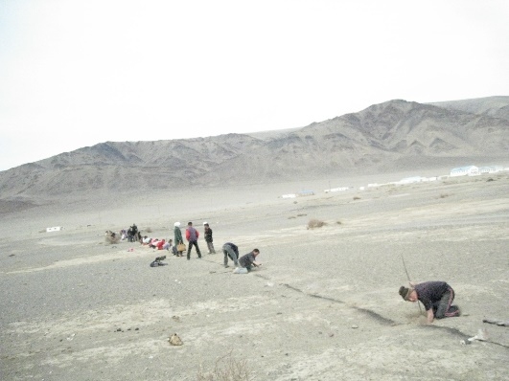 | 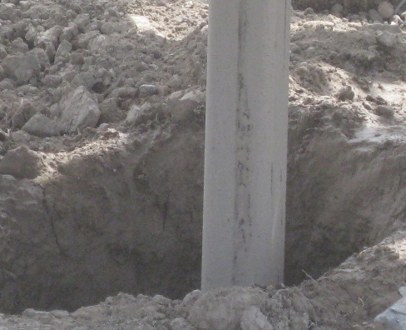 | 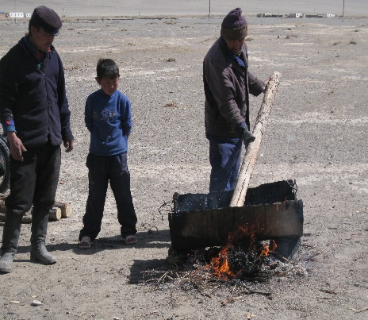
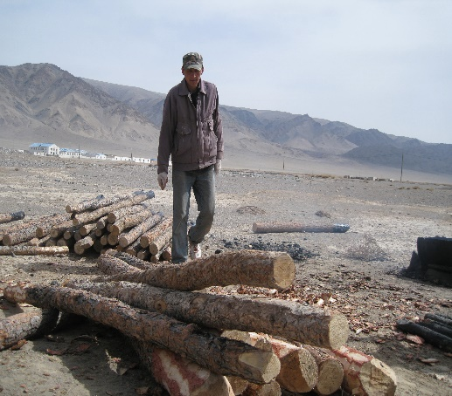 | 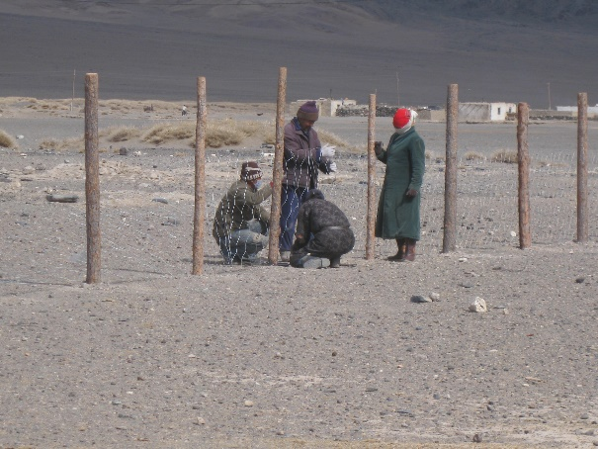 | 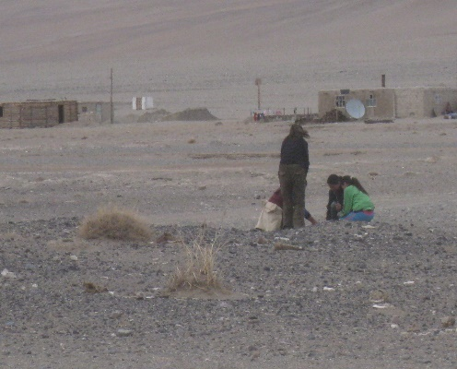
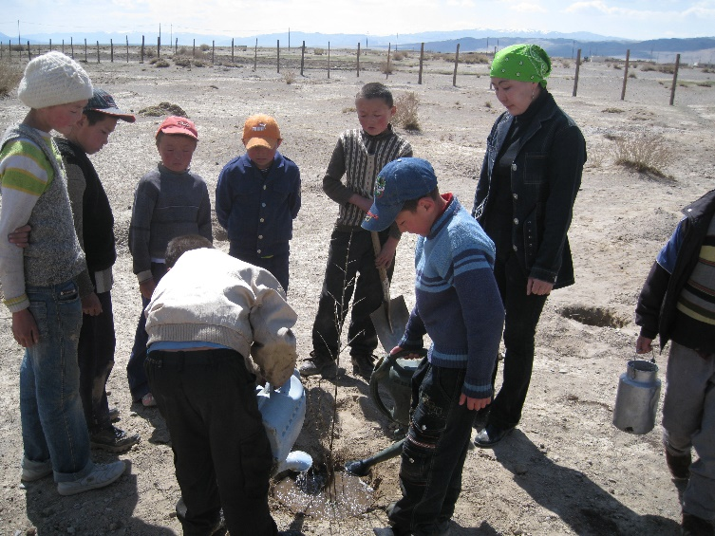 | 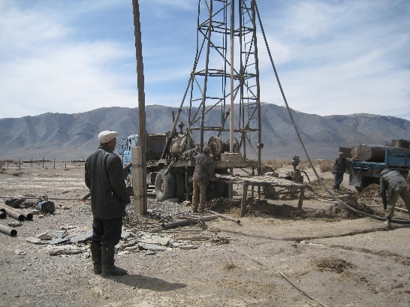 | 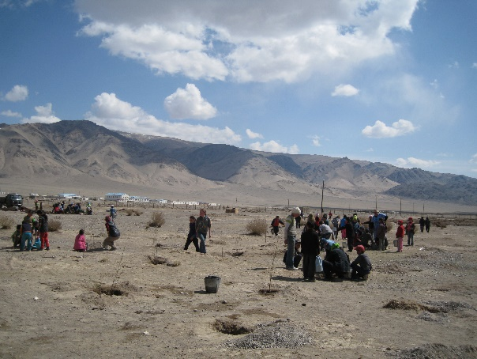
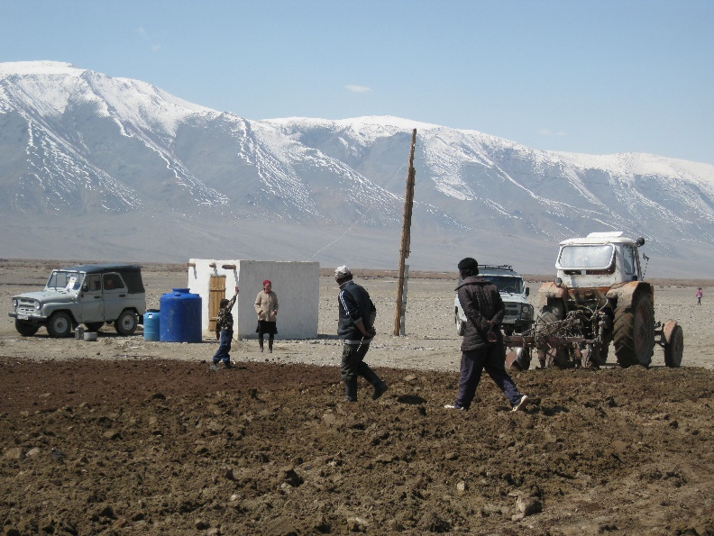 | 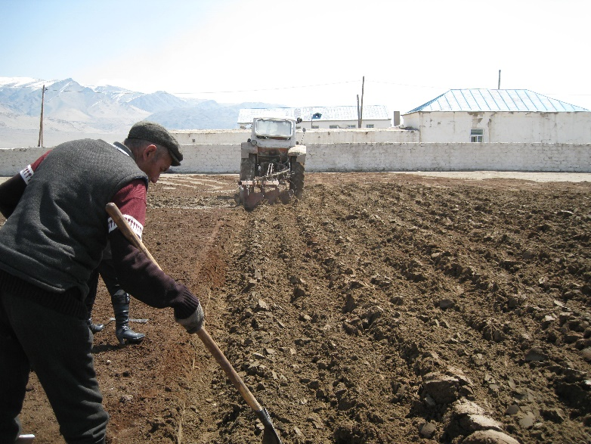 | 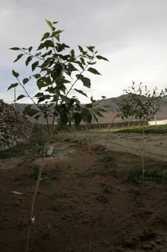
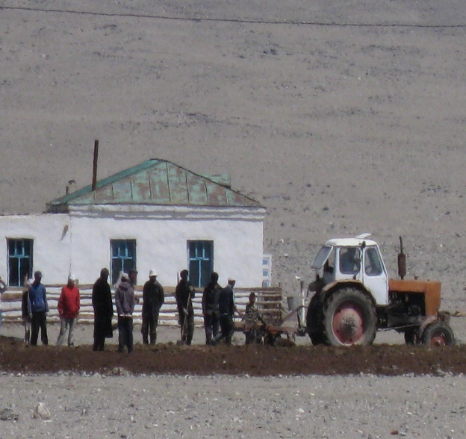 | 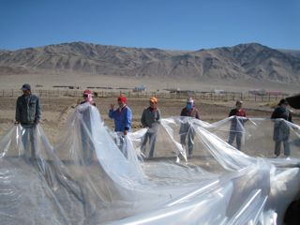 | 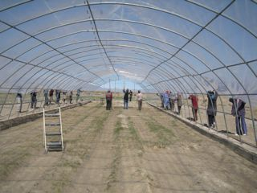
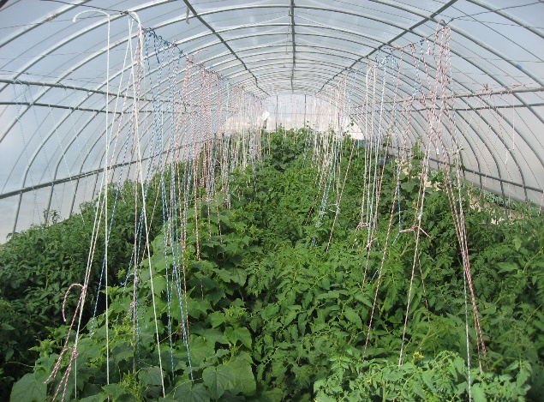 | 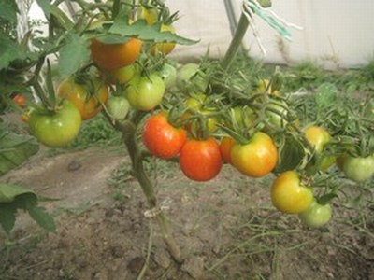 | 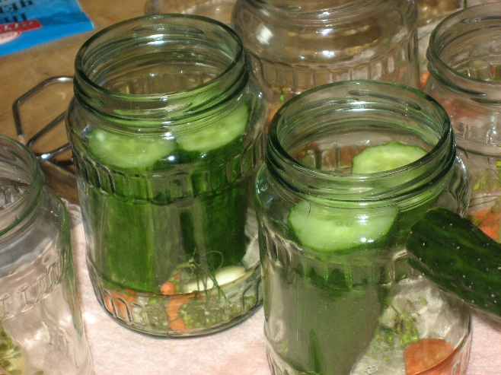
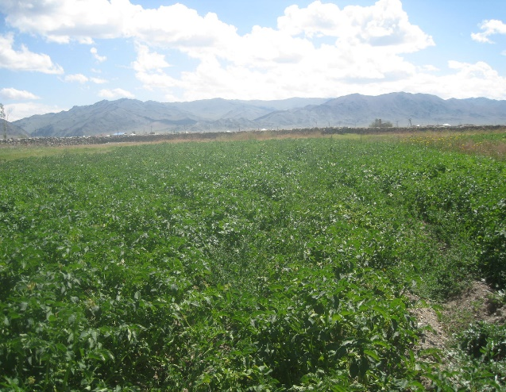

During the summer time, all staff of NGO and extra extra gardeners worked together for wilding, watering and taking care of vegetables. At the end of the September, all community and governors were super surprised when they see the harvest/ result.

Then we had also difficulties. How to store vegetable and how to jarring. So, we solved to build two storages each of them 10 tones.
We brought chef from center of Ulgii to teach cooking classes to the communities. The chef taught classes how to use vegetables to daily food ingredients.

Little by little communities liked delicious meal. Now, Sogoog has 40 families and Ulaankhus has 20 families who has own garden next to their house. Every year , new families who want to have vegetable garden send us request to contribute to “ The Green project”.

Education project:
We opened two kindergartens because there is a big difference between children who grow up at the kindergarten and the children who come to primary school directly from home.
We transferred all assets to local governor so that the kindergarten is sustainable. Now, it is getting fully running budget from Mongolian Education Ministry. Each of them has 125 students and 28 workers and teachers.
We also donated a car by income of Rustic Pathways summer program because we do not have public bus. All families do not live close. Some families’ children come from 8km area, so it is difficult for them to walk during the -30 Celsius. So, a teacher with driver pick children up starting 7:30 till 8:30 a.m. In the evening, they deliver them back to home starting 4:30 till 5:30
Herdsmen family’s children are very shy. They do not spend most of time with their friends.
When they come to primary school they stay at the dormitory and they miss their parents. Because of that, they become homesick and drop out of school.
We also did research between students who live at the dormitory and students who live with their parents. We thought dormitory children would have higher results because they have a lot of free time to do homework. Sadly, it was the opposite. The children who lived at the dormitory had a very low level.
To reduce dropping out of school and to help dormitory children we implemented “Read and Count” projects. Together dormitory teachers and NGO managers helped students to do homework and organized various free time activities. If we push students to do too much homework they will be lazy and bored. If students finish classes earlier and are encouraged to play basketball, to play chess, to see cartoon or comedy …etc, they will love to live at the dormitory and will do homework well. In 6 months, we got exam from them who showed higher results. On top of that, many children also developed their interests to drawing picture and sing a song.etc.
After one year, dormitory students participated in Maths, Chemistry, English and Physics Olympiad. They got awards of “Golden” and “Bronze”.

Health Project:
We are still implementing health projects to dormitory and kindergarten children by Organizing various trainings of hygiene.
For example, how to brush teeth. Because there is no dentist, if they have toothache, it is difficult to take them to Dentist in Ulgii- they need several days and money to pay taxi and treatment.
If there is a hole in their tooth, they will be prone to having big infections. So, it is important to brush their teeth three times a day after meal.
This project was implemented successfully.
We also provided mobile doctors with first-aid supplies and clinics that are located in isolated areas.
Now, all materials are getting old, so we need support to donat some first –aid material.

