Portfolio

João Galrão

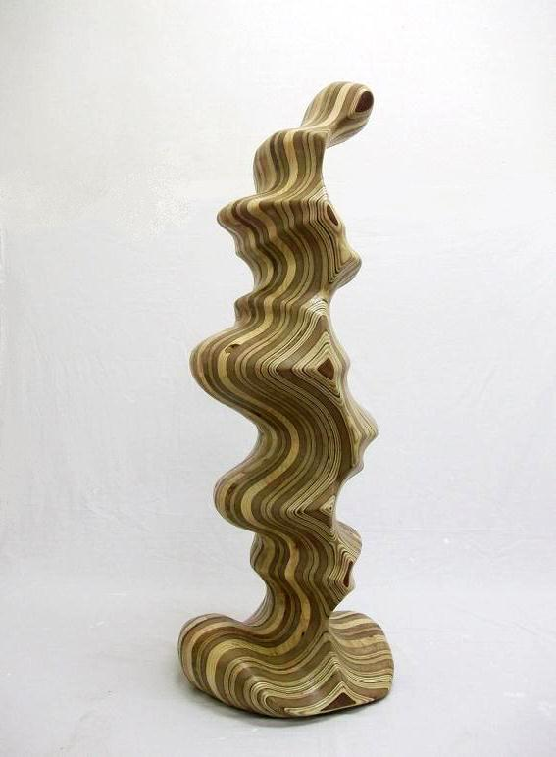

"Big Drop" 1 - Serie " Moments of pleasure" 2012
Wood, acrylic varnish.
114 x 42 x 41 cm
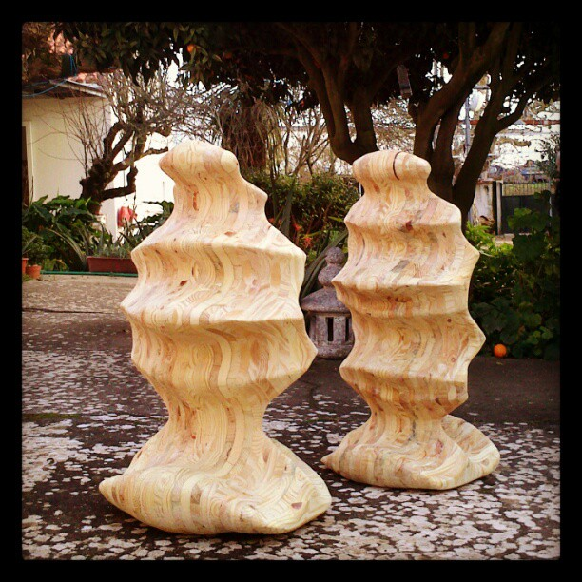
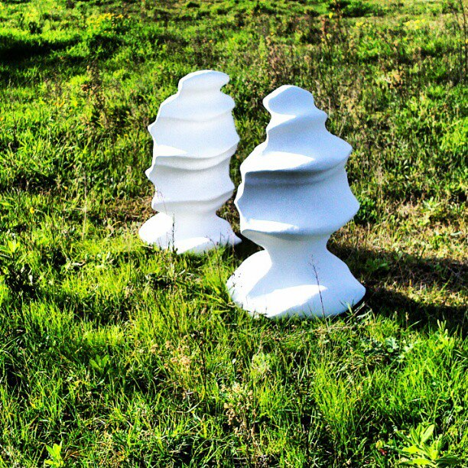

"False Twins" (WIP)
Serie " Moments of pleasure"
Wood, acrylic enamel
80 x 45 x 40 cm (+/- itch)

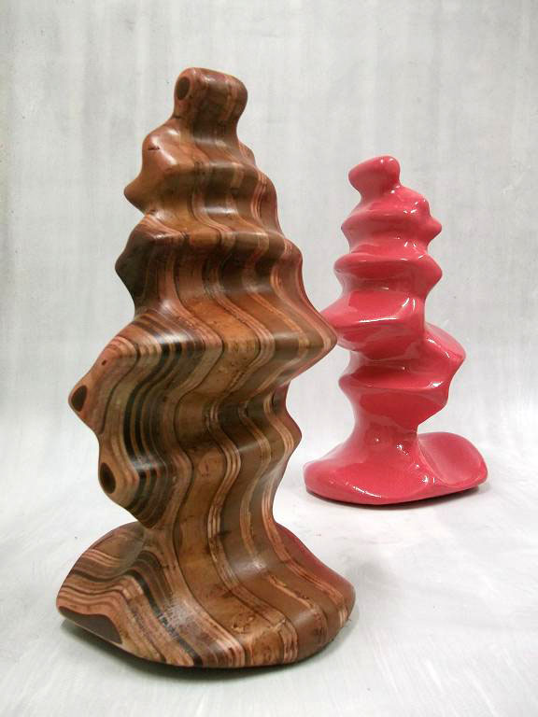

"Little drop" 2012
Wood, acrylic enamel
41x23x14 cm

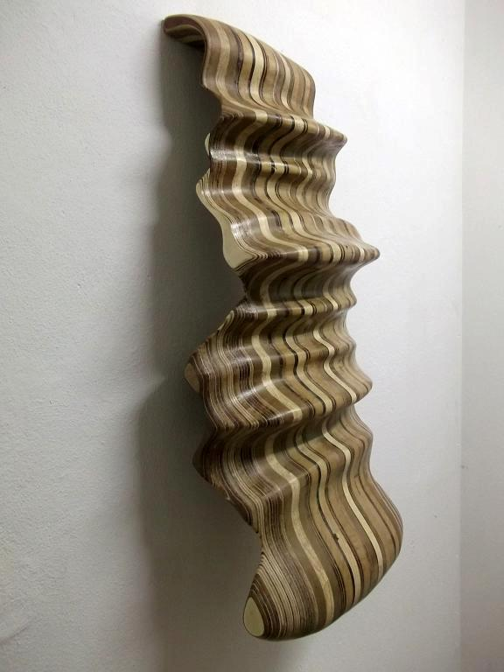

" Large jet" - Serie " Moments of pleasure" 2012
Wood
96 x 48 x 21 cm

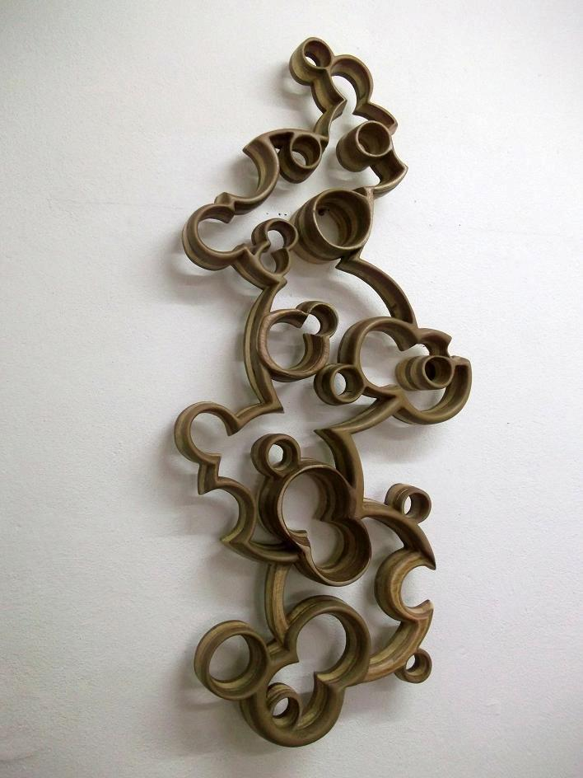

Untitle 2012, Serie Empty Memories
Wood
110 x 49 x 11 cm

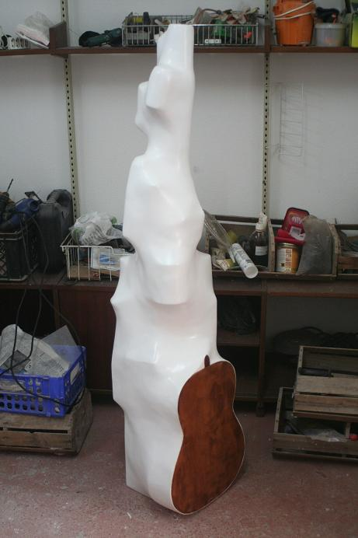

"Viola me" 2011
Held at the Residence Gallery in George Shirley Pictnik
Inorganic waste, wood, gauze, mineral mass and acrylic enamel
150 x 36 x 39 cm

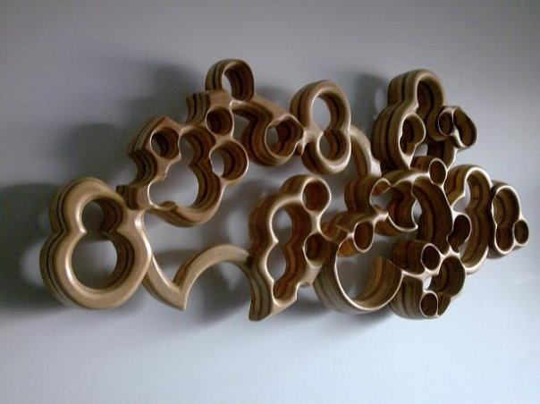

" Empty memories" 3, 2009
wood
146 cm X 60 X 20 cm

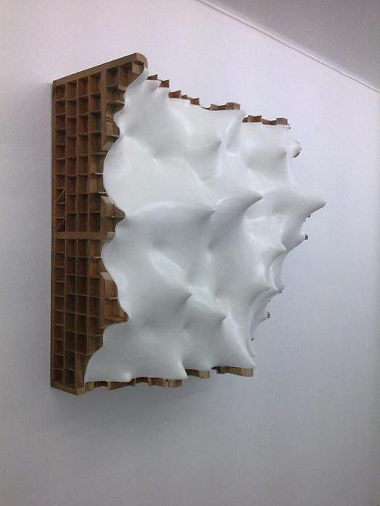

Untitle 2009- Serie “Deadline”
Wood, elastic fabric, mineral mass and acrylic varnish
100 x 100 x 23 cm

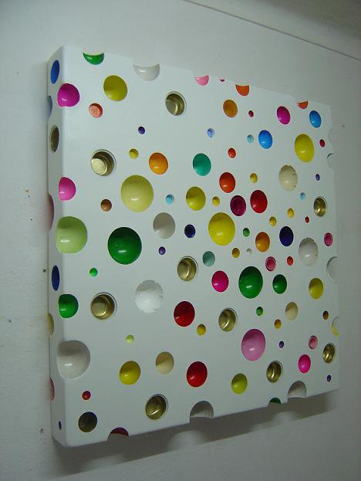

Untitle 2005
Polystyrene foam, gauze, mineral mass, metal,
plastic and acrylic enamel
110 x 110 x 15 cm

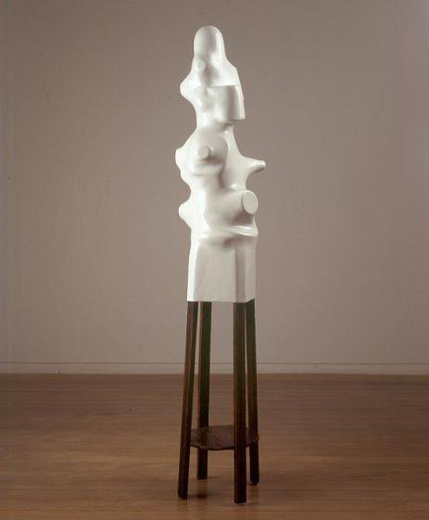

Untitle 2005
Buttonhole of wood, inorganic trash, mineral mass and acrilic varnish
194 x 47 cm (diameter)

João Galrão Visual artist
http://joaogalrao.tumblr.com/
http://joaogalrao.blogspot.pt/
https://www.facebook.com/joao.galrao.visual.artis

Lives and works in Lisbon. From 1996 to 2001 he studied at Ar.Co, Lisbon, where he completed the Advanced Course in Visual Arts in 2001. He has exhibited individually in galleries such as: Graça Brandão, Porto (2003), Hammer Sidi, London (2003), Vera Cortes Art Agency, Lisbon (2005), the Casa Triangulo, Sao Paulo (2005) and Chemistry at The Gallery in Prague (2008)
Since 1996 he has participated in several collective exhibitions, including the Exhibition of Students of Ar.Co (1999, 2000 and 2001) in The Collector's Room, Galeria Canvas, Porto (2002), in 48ème Salon de Montrouge (European Young Creators Salon) Montrouge, Barcelona and Amarante (2003); V Jóvenes Call for Artists, Gallery Luis Adelentado, Valencia (2003) and now as commissioner and one of the intervening artists in the "Afrontamentos" project.
His work lies at the border between painting and sculpture, gives canvases a three-dimensional value obtained though the use of elevations and depressions caused by, previously shaped wood supports, or closer to the present, through the creation geometrical volumes in synthetic material in which multicolored plastic semi spheres are dug into the pieces.

CV

Born in Sintra, Portugal in 1975

Education

1993/1996
- Degree in Preservation and Restoration of Edified Patrimony at EPRP of Sintra, Portugal

1996/2001
- Advanced Fine Arts Degree at Ar.Co - Lisbon, Portugal

Solo Exhibits

2011
- "Meus vícios dentro" - Liberdade Provisória, Lisbon, Portugal
- "Meus vícios dentro" - Drop D, Lisbon, Portugal

2010
- "Little Revelations", Babel Bookstore - Lisbon, Portugal

2008
- "After Hours" - The Chemistry Gallery - Prague, Czech Republic

2006
- "You are now in my dreams" - Graça Brandão Gallery - Porto, Portugal

2005
- "Contratempo" - Vera Cortês Art Agency - Lisbon, Portugal
- "Antes de Partir" - Casa do Triângulo - São Paulo, Brazil
- "After Hours" - Projecto Gallery - Vola Nova de Cerveira, Portugal

2003
- Graça Brandão Gallery - Porto, Portugal (catalog)
- Hammer Sidi - London, England
- "Peridos e Achados" - Castelo 66 Gallery - Lagos, Portugal

Collective Exhibits

2012
- "God Factor", São Martinho de Tibães Monestary - Braga, Portugal
- "Isto também sou eu / I'm this also", Liberdade Provisória - Lisbon, Portugal

2011
- "Afrontamentos 6", Casa da Artes, Brejoeira Pallace, Monção, Portugal

2010
- "Hard Feelings", Comunications Museum, Lisbon, Portugal
- "Display objects, Buildings and Space", Experimenta, Calhariz Pallace, Lisbon, Portugal
- "Pieces and Parts", Plataforma Revolver Gallery, Lisbon, Portugal

2009
- "Livingart Project", Congress Hotel & Spa - Porto, Portugal
- "Afrontamentos 5", Quase Galeria - Espaço T - Porto, Portugal
- "Afrontamentos 4", Jorge Shirley Gallery - Lisbon, Portugal

2006
- "Home Sweet Home", São João da Madeira Art Centre - São João da Madeira, Portugal
- "3+3", Ficha Tripla (?)
- "Constelações Afectivas", Graça Brandão Gallery - Lisbon, Portugal

2005
- "Paisagens e Arquitecturas", Sete Gallery - Coimbra, Portugal
- "Densidades Relativas", Calouste Gulbenkian Fundation - Lisbon, Portugal
- "Alquimia", Quinta de Regaleira - Sintra, Portugal

2003
- "V Convocatória Internacional de Jóvenes Artista", Luís Adelentado Gallery - Valencia, Spain
- "48ème Salon Montrouge" - Salão Europeu de Jovens Criadores - Arte Contemporânea
- "Quarto Formas d'Art", Formadarte Gallery - Estoril, Portugal

2002
- "Os 4 Elementos", Casa Municipal da Cultura, Museu da Pedra - Cantanhede, Portugal
- "O quarto do Coleccionador", Canvas Gallery - Porto, Portugal

2001
- Senior Students Exhibit of Ar.Co, Sala Jorge Vieira - Lisbon, Portugal

2000
- "2000 Greenspaces" colaboration with Armanda Duarte, Estufa Fria - Lisbon, Portugal
- "No Bazar de Harry", Fitares Gallery - Rio de Mouro, Portugal
- "Exposição dos Alunos da Ar.Co", Quinta de São Miguel - Almada, Portugal

1999
-"Ramaia" - Vila do Bispo, Portugal
- "D. Fernando II", Casal de São Domingos Gallery - Sintra, Portugal
- "RAMA", Alvarez Gallery - Porto, Portugal
- Ar.Co's Summer Exhibit - Lisbon, Portugal

1997
- "RAM" - Lisbon, Portugal

1996
- "Jov'Arte 96" - Loures, Portugal

Filmography
- Intervew for the Portuguese Art Institute in "Afrontamentos 6" collective exhibit, Brejoeira Pallace - Monção, Portugal
- Movie for posterity by Álvaro Queiroz in the artists study, Sintra; for the collection of the "Cinemateca Portuguesa - Anim

Collections
- Modern Art Centre of Caloust Gulbenkian Fundation - Lisbon, Portugal
- PLMJ Fundation - Lisbon, Portugal
- Bergé Collection - Spain
- Elvas Modern Art Museum - Elvas, Portugal

